Entrepreneurship education: Relationship between education and entrepreneurial activity
Mario Raposo and Arminda do Paco
University of Beira Interior

The importance of entrepreneurial activity for the economic growth of countries is now well established. The relevant literature suggests important links between education, venture creation and entrepreneurial performance, as well as between entrepreneurial education and entrepreneurial activity. The primary purpose of this paper is to provide some insights about entrepreneurship education. The meaning of entrepreneurship education is explained, and the significant increase of these educational programmes is highlighted. Literature has been suggesting that the most suitable indicator to evaluate the results of entrepreneurship education is the rate of new business creation. However, some studies indicate that the results of such programmes are not immediate. Therefore, many researchers try to understand the precursors of venture creation, concluding that is necessary to carry out longitudinal studies. Based on an overview of the research published about the existing linkage of entrepreneurship education and entrepreneurial activity, the main topics studied by different academics are addressed. For the authors, the positive impact of entrepreneurship education puts a double challenge on governments in the future: the increased need of financial funds to support entrepreneurship education and the choice of the correct educational programme.

Entrepreneurship has emerged over the past three decades, as arguably the most potent economic force that the world has ever seen. The focus of economic development, and even of collegiate business programs, has shifted more heavily toward entrepreneurship. This increased interest in the entrepreneur's role in the economy has led to a growing body of research attempting to identify the factors that promote entrepreneurship.
The level of entrepreneurship differs considerably across countries and over the time. Both causes and consequences of entrepreneurship are a matter of significant and extensive debate among scientists, policy makers and governments. A high level of entrepreneurial activity is assumed and shown to contribute to foster competition, innovation, economic growth, job creation and well being of the citizens.
According to Global Entrepreneurship Monitor (GEM) (2008) there is wide agreement on the importance of entrepreneurship for economic development. Entrepreneurs drive innovation: they speed up structural changes in the economy and force old incumbent companies to shape up thereby making an indirect contribution to productivity.
To Verheul, Wennekers, Audretsch and Thurik (2001), a broad range of determinants explains the level of entrepreneurship, including economic and social factors. Moreover, it is generally accepted that policy measures can influence the level of entrepreneurship. The public policy can exert influence on entrepreneurship in different ways: directly through specific measures and indirectly through generic measures. For example, when stipulating competition policy, the government can influence the market structure and (indirectly) the number and type of entrepreneurial opportunities.
Also the government can influence the rate of entrepreneurship not only through legislation, but also through the educational systems. Education seems important for stimulating entrepreneurship because several reasons (Reynolds, Hay, & Camp, 1999; Sánchez, 2010a). First, education provides individuals with a sense of autonomy, independence, and self-confidence. Second, education makes people aware of alternative career choices. Third, education broader the horizons of individuals, thereby making people better equipped to perceive opportunities, and finally, education provides knowledge that can be used by individuals to develop new entrepreneurial opportunities.
Entrepreneurs are not «born» rather they become through the experience of their lives. Through effective entrepreneurship education an individual can access the skills and knowledge needed to start and grow up a new business. Peter Drucker, one of the leading management thinkers of the last century, questioned: «Is the entrepreneurial mystique?». His answer is that it is not magic, it is not mysterious and it has nothing to do with genes. It is a discipline and, like any discipline it can be learned (Drucker, 1985). According Kuratko and Hodgets (2004), entrepreneurship is a dynamic process of vision, change and creation. It requires an application of energy and passion towards the creation and implementation of new ideas and creative solutions. In this light, entrepreneurship is more than the simple business' creation.
To Kuratko (2005), an entrepreneurial perspective can be developed in individuals. This perspective can be exhibited inside or outside an organization, in profit or non-profit organizations, and in business or non business activities, for the purpose of bringing forth creative ideas. The entrepreneurship is an integrated concept that permeates an individual's business in an innovative manner. It is this perspective that has revolutionized the way business is conducted at every level an in every country. The revolution has begun in an economic sense, and the entrepreneurial perspective is the dominant force.

According the Small Business Economic Report (2006), a review of recent research measuring the impact of general education on entrepreneurship and entrepreneurial performance suggests three key generalizations. First, the evidence suggesting a positive link between education and entrepreneurial performance is robust. Second, although the link between education and selection into entrepreneurship is somewhat ambiguous, evidence suggests that when «necessity entrepreneurship» and «opportunity entrepreneurship» are considered separately, and when country difference is considerate, the link is less ambiguous. Finally, the relationship between education and selection into entrepreneurship is not linear in nature. The highest levels of entrepreneurship are linked to individual with at least some colleague education.
In spite of the contemporary variation of entrepreneurship definitions there are some similarities. Most part of the research considers that entrepreneurship «is located» within the entrepreneur, to a limited number of characteristics or behaviours usual for the entrepreneurial personality despite its environment (Holmgren, From, Olofsson, Karisson, Snyder, & Sundtröm, 2004; Sánchez, 2010b).
This article aims to address some of the issues surrounding entrepreneurship education. After the initial contextualization, the authors will try to explain the meaning of entrepreneurship education. The discussion on this problematic will lead us to next point ofthe paper: «Which are the main research lines in the field of entrepreneurship education?» and «What topics should be explored in the future?».

What is entrepreneurship education?
Hansemark (1998) states that traditional education is marked as only a transformation of knowledge and abilities, while entrepreneurship education, in contrast, is held up as the model for changing attitudes and motives. Entrepreneurship and entrepreneurship education, beside evident advantages, like promoting business start-ups, has also a wider market potential (Holmgren et al., 2004).
Two of the more important prerequisites for success, in starting a new business, are the desire or the ability to do so. Entrepreneurial attitudes are not only required in the course of a classic entrepreneurial career, but they are also cleariy in high demand independent employment relationships (Frank, Korunka, Lueger, & Mugler, 2005).
Entrepreneurship education seeks to propose people, especially young people, to be responsible, as well as enterprising individuals who became entrepreneurs or entrepreneurial thinkers who contribute to economic development and sustainable communities.
According to the European Commission communication «Fostering entrepreneurial mindsets through education and learning», entrepreneurship education can be defined as it follows: «Entrepreneurship refers to an individual's ability to turn ideas into action. It includes creativity, innovation and risk taking, as well as the ability to plan and manage projects in order to achieve objectives. This supports everyone in day-to-day life at home and in society, makes employees more aware of the context of their work and better able to seize opportunities, and provides a foundation for entrepreneurs establishing a social or commercial activity» (Commission of the European Communities, 2006: 4).

The Consortium for Entrepreneurship Education (2008) states that entrepreneurship education is not just about teaching someone to run a business. It is also about encouraging creative thinking and promoting a strong sense of self-worth and empowerment. Through entrepreneurship education, students learn how to create business, but they also learn a lot more. The core knowledge created via entrepreneurship education includes:
- The ability to recognize opportunities in one's life.
- The ability to pursue opportunities, by generating new ideas and found the needed recourses.
- The ability to create and operate a new firm.
- The ability to think in a creative and critical manner

So, beside knowledge and skills in business, entrepreneurship education is mainly about the development of certain beliefs, values and attitudes, with the aim to get students to really consider entrepreneurship as an attractive and valid alternative to paid employment or unemployment (Holmgren et al., 2004; Sánchez, 2010a).
Given the proliferation of entrepreneurship education, it is necessary to organize this topic framework. Jamieson (1984) suggested a three-category framework. The author distinguishes between education about enterprise, education for enterprise and education in enterprise, recognising the roles that the different types of education represent. The first category deals mainly with awareness creation, and has the aim of educating students on the issues about setting up and running a business (from a theoretical perspective). Enterprise modules within business and other courses at undergraduate or postgraduate level can also be included in this category.
Education for enterprise, the second category, deals more with the training of aspiring entrepreneurs for a career in selfemployment with the aim of encouraging participants to set-up and run their own business. Individuals are taught the practical skills required for business management. The courses are often directed towards the preparation of a business plan. Business startup and «start your own business» would be examples of this type of entrepreneurship training.
The third category, education in enterprise, includes management training for established entrepreneurs and focuses on ensuring the expansion and development of the business. Examples of these programmes can be the business management and growth training, product development and marketing courses. Such training provides skills, knowledge and attitudes for entrepreneurs to go out and innovate and solve their own, and the firm, problems.
By its turn Garavan and O'Cinnéide (1994) adopted a broader view to categorizing entrepreneurship education and training, differentiating between entrepreneurship education and education and training for small business owners. The first category is described by them as «entrepreneurial education which is aimed at providing an opportunity to learn about the conditions favouring new business creation, as well as the various theories concerning the type of characteristics requiredfor successful entrepreneurship» (Henry, Hill, & Leitch, 2005: 5).

However Garavan and O'Cinnéide (1994) were more focused on education and training for small business owners and have classified the type of training into three categories, which seems to be related to the individual's stage of development: (i) business awareness education that usually appears in secondary school; (ii) in field education and training for small business ownership; (iii) more specialist education conceived to enable people to update their skills.
According to these authors the most usually referred aims of entrepreneurship education are the following:
- To get knowledge useful to entrepreneurship.
- To increase capacities in the use of techniques, in the examination of business situations, and in the creation of action plans.
- To identify and stimulate entrepreneurial skills.
- To develop empathy and support for all issues of entrepreneurship.
- To develop attitudes towards change.
- To promote new start-ups and other ventures.
For the purposes of this paper we opt to make a clear distinction between «enterprise education» and «small business and entrepreneurship education and training». The most relevant objectives of enterprise education are to develop enterprising people and encourage an attitude of autonomy using suitable learning processes. The entrepreneurship education and training programmes are aimed directly at stimulating entrepreneurship (mostly directed to entrepreneurs whose aim is the development of opportunity-seeking within firms).
Most researches about entrepreneurship education are mainly focuses in the university level (e.g.. Raposo, Ferreira, Paco, & Rodrigues, 2008; Sánchez, 2009) or in the secondary school (e.g., Paco, Ferreira, Rodrigues, & Dinis, 2008; Rodrigues, Dinis, Paco, & Ferreira, 2008). However several authors recommend that this educational process begins earlier. For example Landström and Sexton (2000) refer that children are seen as entrepreneurial by birth. Therefore entrepreneurship education should begin at the youngest age possible.
It is imperative to have in mind that entrepreneurship and entrepreneurship education, from an early age in one's life, does not only concern business, start-ups and new ventures. Entrepreneurship has mostly to do with the ability that an individual has to turn his/her inspirations into actions.
With more education and encouragement, youth should be able to realize their entrepreneurial aspirations. This outcome will increase economic growth in communities and open new job and career opportunities, regardless of economic circumstances. Although not all youth will become entrepreneurs, all students and society benefit when individuals have a solid education, that gives them entrepreneurial knowledge and skills to use over their lifetime.

Some research perspectives on entrepreneurship education
A considerable number of varieties of topics approaches and directions are reflected in the papers published around the thematic of entrepreneurship education, both conceptual and empirical. An interesting survey of entrepreneurship education research published between 1985 and 1994, based in leading academic journals, was conducted by Gormon, Hanlon and King (1997). They suggested that the central theme in the research they reviewed was the extent to which formal education can contribute to entrepreneurship. They argued that the existing empirical research published, during the time period of their review seems to suggest a consensus among researchers that entrepreneurship can be taught and that entrepreneurial attributes can be positively influenced by educational programmes.
An overview of research published between 1995 and 2005 about the existing research linking various forms of entrepreneurial education to entrepreneurial activity, specifically, empirical studies linking education both to the act of venture creation and to those antecedents that have been proposed as directly linked to entrepreneurial activity, was presented in the report published in 2006 «The Small Business Economy - a Report to the President of USA». The articles were drawn from a wide range of peer-reviewed journals and also from the proceedings of three entrepreneurship focused Organizations of United States: USASBE (United States Associations for Small Business and Entrepreneurship), ICSB (International Council for Small Business and Entrepreneurship) and The Babson-Kauffman Entrepreneurship Conference.
Based in this report, the table 1 shows the main topics studied and supported by the contributions of different authors.
Research implications

Based in the state of entrepreneurship education research, it is possible to say that there are indications of a possible link between entrepreneurial education and subsequent entrepreneurial activity. The evidence also suggests that there might be a long period of time between the education experience and subsequent action.
The results reported by European Commission (2008) point that entrepreneurship education is first and foremost provided in business-related courses. However the methods and curriculum do not always seem to be the most efficient and communicable for the students.
In this sense the EU Member States have recognized the need of entrepreneurship education to be integrated in theofficial educational curricula. Nevertheless, changes still need to be carried out to make possible this implementation. The total number of countries of the EU that have integrated entrepreneurship into their curricula is very low. So it is necessary to promote the inclusion of entrepreneurship as a key competence in the all members' national programme. For this reason, additional research should be conducted to define the necessary knowledge, skills and competences, in the field of entrepreneurship, that are necessary for individuals to enter the labour market and to become entrepreneurs. This extensive study could contribute to the design of better educational programmes. At the same time, a better knowing of the entrepreneurial skills and competences, and its dissemination, could «convince» more countries to adopt such programmes in the official school.
There are also two fundamental issues that should be analyzed in an interdependent way: the role of educators and teachers and the role ofthe nuclear family. They are really fundamental to influence a child to become an entrepreneur? How they can motivate the young people to be more autonomous and entrepreneur? Entrepreneurship education demands a certain amount of time. Single courses and learning experiences are not enough, and should be integrated in
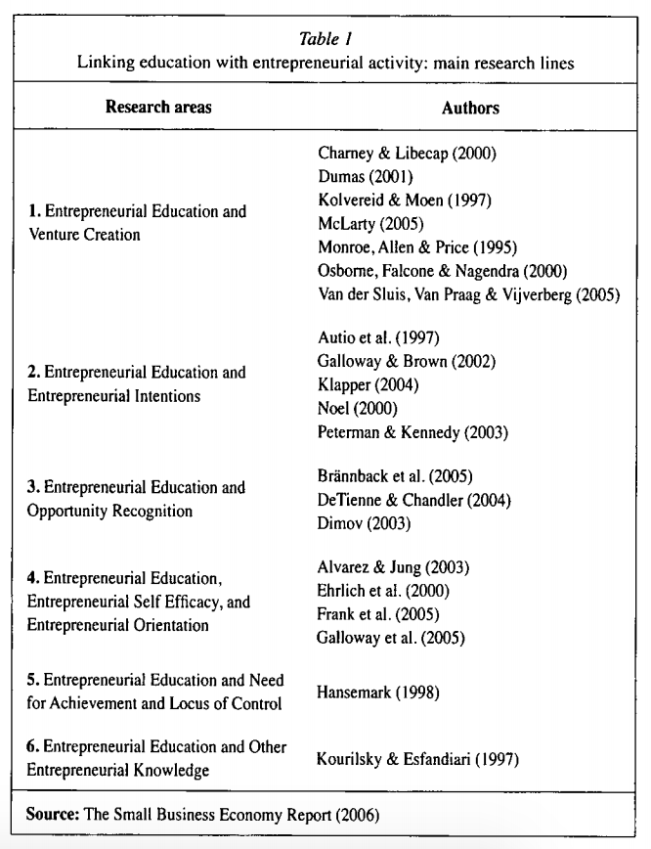
all regular teaching activities and at all levels of the educational system. In this sense teachers and parents have a fundamental function in the promotion and flourish of entrepreneurship. These aspects should be more carefully explored.
The lack of knowledge about effective teaching techniques for entrepreneurial educators is underlined as a problem, caused by that research on how to teach entrepreneurship is underdeveloped (Holmgren et al., 2004).
It seems that throughout the time the research is been putting too much an emphasis on knowledge and not enough emphasis on competence, or even too much attention on information transfer learning methods and not enough attention on individual small group learning methods (ex. project teams, peer exchange, individual counselling). There is very little evaluation of the effectiveness of education entrepreneurship programmes. There is a lack of evidence on how learning strategies influence the development of entrepreneurial competence and how these competences transfer into new venture. Thus, these topics should be also explored in future.

Conclusions
The primary purpose of this conceptual article was to provide a review of relevant literature about the links between entrepreneurship education and entrepreneurial activity.
The educational system influences the knowledge base, the achievement of skills, competences and attitudes on which future career choices are based. Since these decisions are essential to the future of the individual, school has the responsibility to inform and expose students to a wide range of career options, including entrepreneurship.
The literature review done had provided some indications about a positive link between entrepreneurial education and subsequent entrepreneurial activity. This evidence provides reasons to support opportunities for people of all ages to take part in education efforts. Additionally, the education and training should center itself much more in changing personal attitudes than in knowledge, because the effects could be more significant to the process of business creation and to overcome the perceived barriers to entrepreneurship. The educational systems need to be oriented to emphasize and value entrepreneurship in order to promote an enterprise culture.
In future the methodologies associated with the entrepreneurship education could be an interesting topic to be studied. It is important to understand what is being done in several pilot schools in order to analyze the best practices. The correct teaching methodology and the right learning process will certainly be crucial to the success of the entrepreneurship education programme.
The growing interest in entrepreneurship education and the research regarding the impact of such education present some important policy question both for the institutions that deliver entrepreneurship education programmes and for support organizations that provide funding.

